**Max Elvis Hegarty**

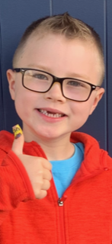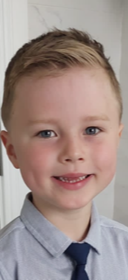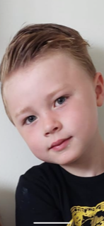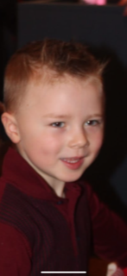

**PERSONAL STATS**

DOB: 29/12/2016

Height: 4ft

Weight: 4 stone 3 pounds

Hair Color: Light Brown

Eye Color: Bright Blue

Shirt size: 7/ 8UK

Pant Size: 7/ 8UK

Shoe Size:

PARENTS CELL #: 00353 (86) 7940901

PARENTS EMAIL: [segarty@gmail.com](mailto:segarty@gmail.com)

**TRAINING**

**Workshop Name: Oct/Nov 2022**

**Coaches: Hannah Kat Jones , Karen Gonzalez & Jimmy Bellinger**

* Basic Acting Principles
* Audition Techniques
* Monologue Preparation
* Improvisation

**Singing:**

Elvis & Modern Day Pop

**SPECIAL SKILLS**

Swimming,Football

**PERSONAL INTERESTS**

Max is very creative. When he isn’t acting or making youtube videos he loves drawing & painting. He also likes playing the PlayStation and watching gaming videos